3. Git HandsOn

Please follow the instruction to complete the hands-on. Each instruction expects a command for the Git Bash.
Branching:
- Create a new branch “GitNewBranch”.
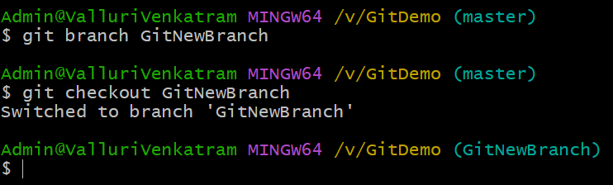

- List all the local and remote branches available in the current trunk. Observe the “*” mark which denote the current pointing branch.
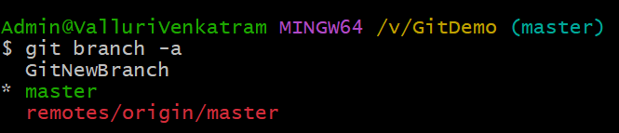
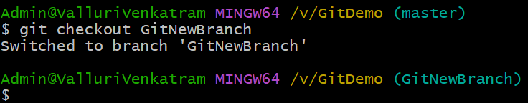
- Switch to the newly created branch. Add some files to it with some contents.

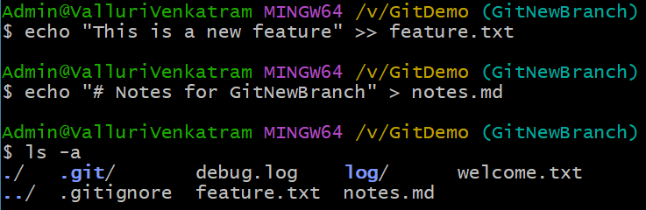
- Commit the changes to the branch.
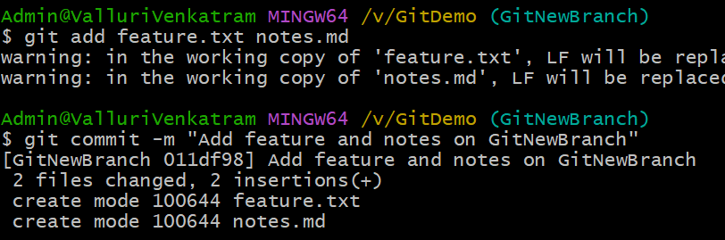
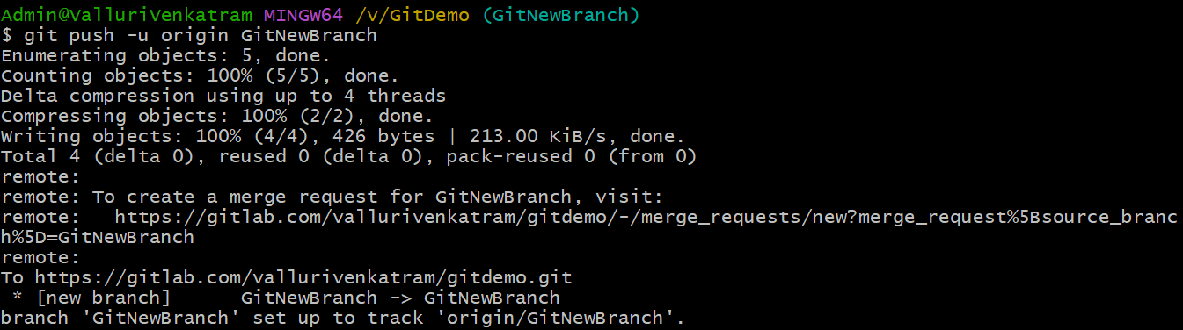
- Check the status with “git status” command.
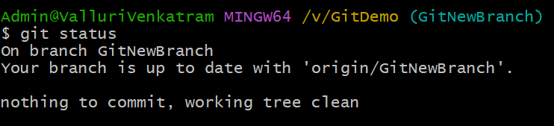
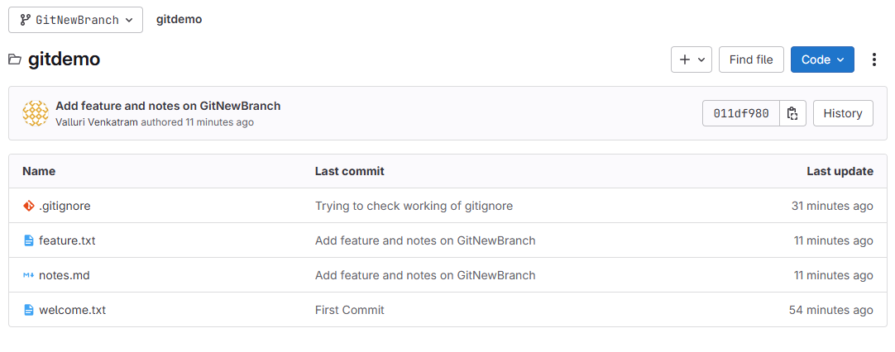

Merging:
- Switch to the master
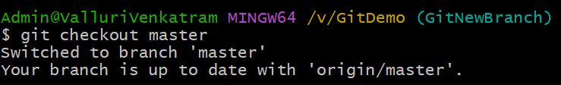

- List out all the differences between trunk and branch. These provide the differences in command line interface.
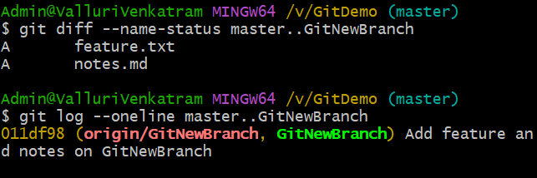
- List out all the visual differences between master and branch
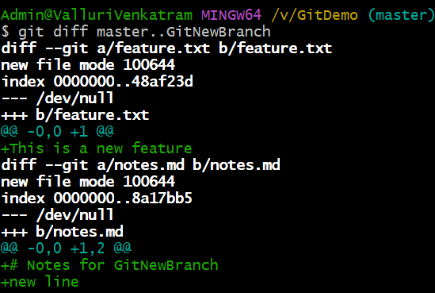

- Merge the source branch to the trunk.
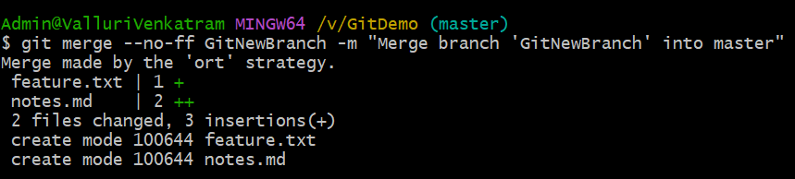

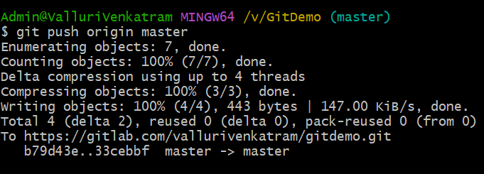
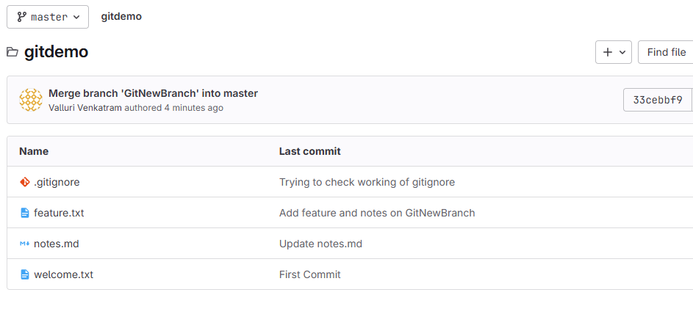

- Observe the logging after merging using “git log –oneline –graph –decorate”
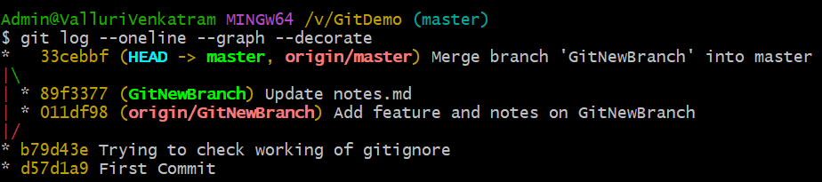
- Delete the branch after merging with the trunk and observe the git status.
